EX-1:

CREATE TABLE time_ex1 (exact_time TIMESTAMP);

INSERT INTO time_ex1 VALUES ('10-Jun-2017 10:52:29.123456');

INSERT INTO time_ex1 VALUES (SYSDATE);

INSERT INTO time_ex1 VALUES (SYSTIMESTAMP);

SELECT * FROM time_ex1;

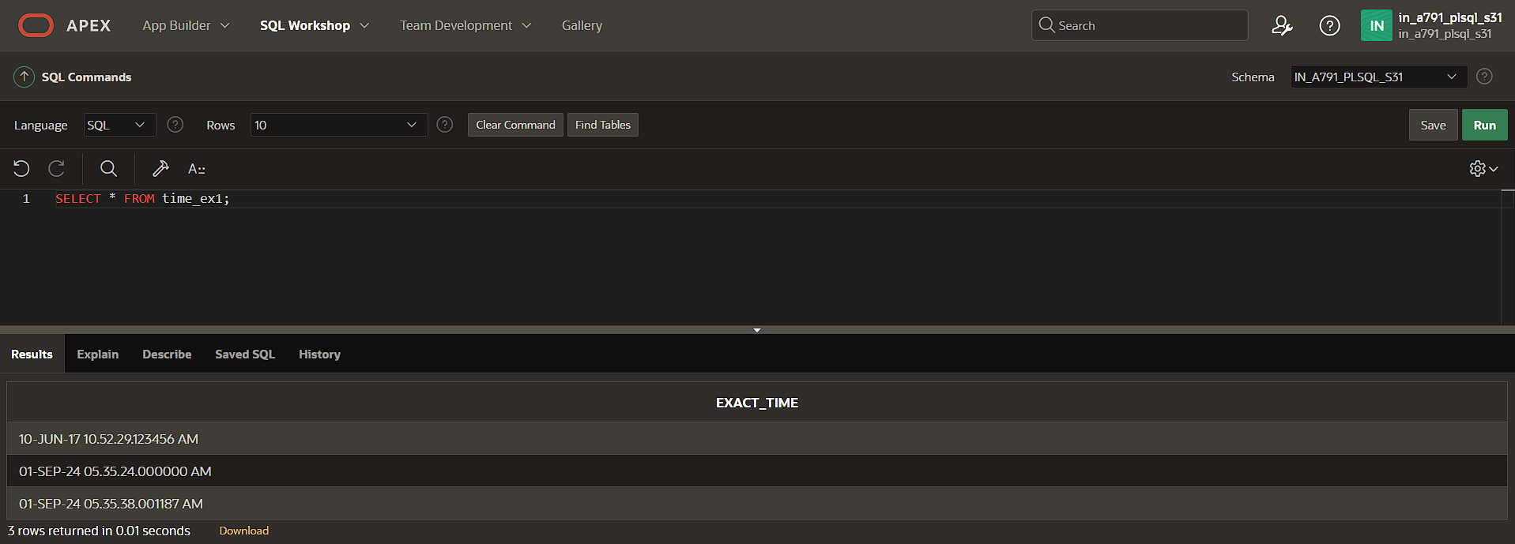

EX-2:

CREATE TABLE time_ex4 (loan_duration1 INTERVAL YEAR(3) TO MONTH, loan_duration2 INTERVAL YEAR(2) TO MONTH);

INSERT INTO time_ex4 (loan_duration1, loan_duration2) VALUES (INTERVAL '120' MONTH(3), INTERVAL '3-6' YEAR TO MONTH);

SELECT * FROM time_ex4 ;

